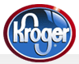 Kroger Rewards Program and Granville Music Boosters
If you shop at Kroger, please sign up for the community rewards program that benefits your Granville Music Boosters. It is easy, BUT you MUST sign up every April to continue. And this program does not affect your fuel rewards.
Go to: www.krogercommunityrewards.com
Log in: 1. If you have never logged in, please sign up.
2. If you don’t know your account information, call 1-614-898-3578

Click on Columbus Stores:
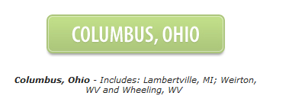
Click on Enroll:
Find your organization, enter code 81408, and click search.
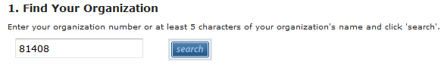
Confirm the organization by clicking on the button next to our name.
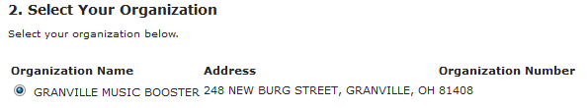
Save.
